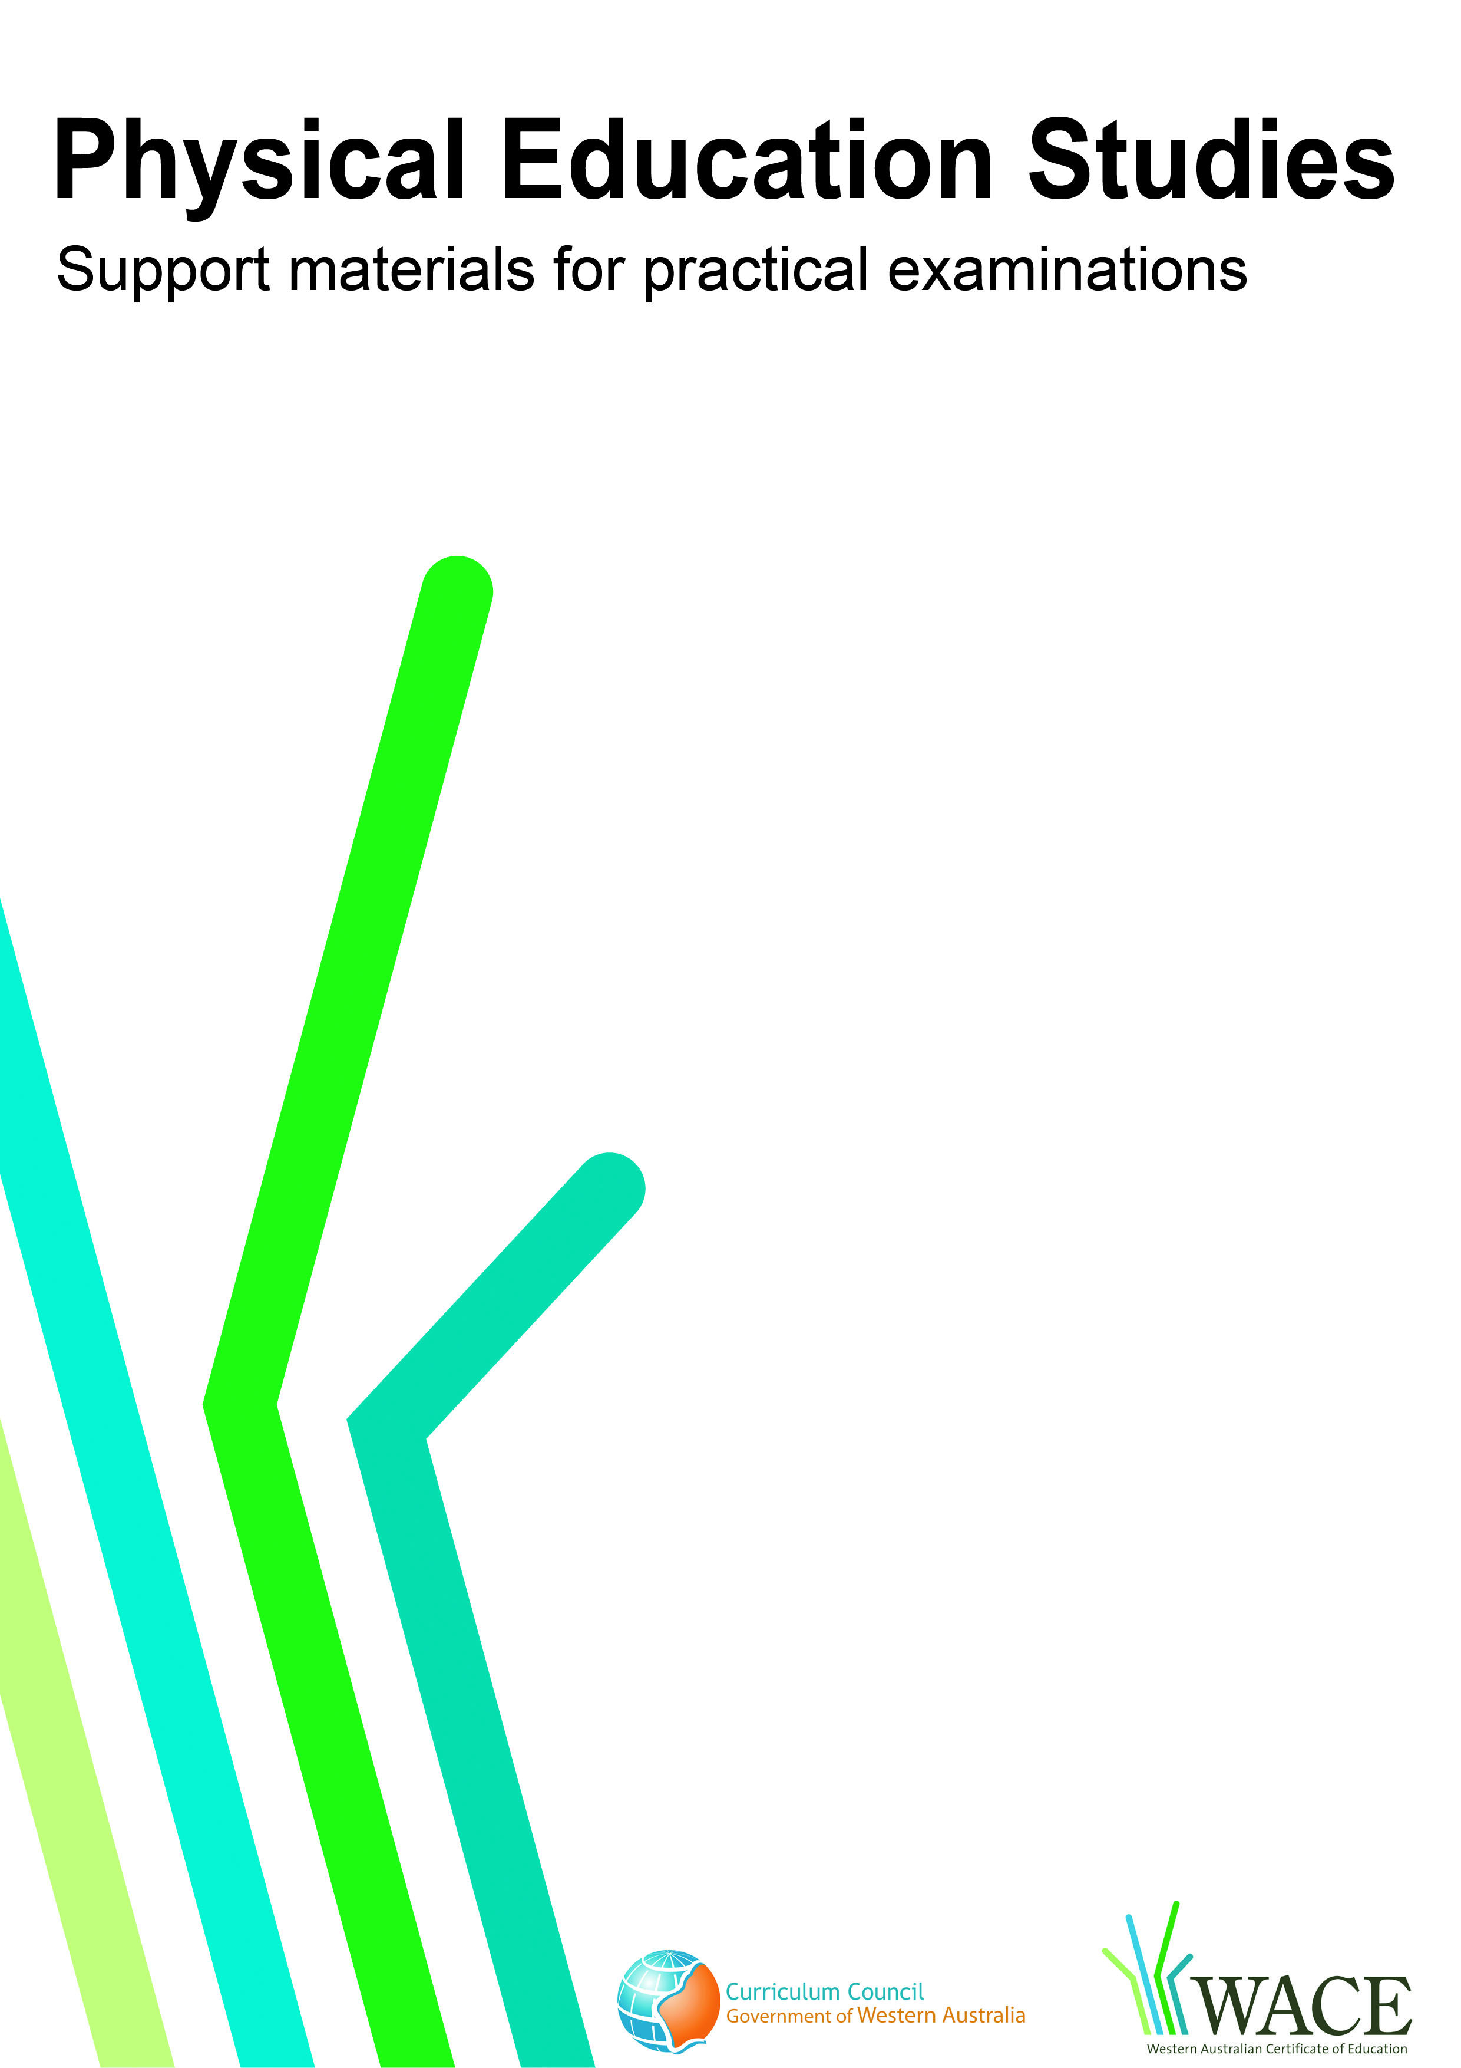

23 April 2009
Basketball

© Curriculum Council, 2011
This document—apart from any third party copyright material contained in it—may be freely copied, or communicated on an intranet, for non-commercial purposes by educational institutions, provided that it is not changed in any way and that the Curriculum Council is acknowledged as the copyright owner.
Copying or communication for any other purpose can be done only within the terms of the Copyright Act or by permission of the Curriculum Council.
Copying or communication of any third party copyright material contained in this document can be done only within the terms of the Copyright Act or by permission of the copyright owners.
Version 5

Introduction
The purpose of these materials is to support teachers and candidates in preparation for the Physical Education Studies practical examination.

Skills set for basketball
These materials outline the examinable skills set for basketball. Five (5) of the skills, selected by the examination panel, will be examined and these will be communicated to the candidates at the commencement of the examination.

Observation points
Observation points are provided for each skill in the skills set. They are provided for the purpose of teaching and coaching and are designed to assist examination candidates in their personal skill development.

Examination drills
The examination will contain a number of drills through which the selected skills will be assessed. These materials outline a number of drills indicative of the types of drills in which the candidates will participate during the examination and may form part of a teaching program.

Tactical framework
In the conditioned performance section of the examination, candidates will participate in a modified competitive situation, which will be based on some of the tactical problems in basketball. The tactical problems for the examination are outlined in the tactical framework and will be selected by the examination panel. The skills that provide the basis for the solutions to these tactical problems are also included in the framework.

In the conditioned performance section of the basketball examination, students will be assessed on the execution of skills, use of space, positioning and decision making that effectively solve the tactical problems presented by the modified competitive situation..

CONTENTS | PAGE NUMBER
Basketball skills set | 5
Skills set and observation points | 6
Basketball drills | 11
Drill descriptions | 12
Tactical framework | 30

Skill number | Name of skill | Page number
1 | Control dribble | 6
2 | Speed dribble | 6
3 | Offensive stance – triple threat (TT) | 6
4 | Leading – wing lead | 7
5 | Closeouts – wing closeouts | 7
6 | Shooting – free throw | 7
7 | Lay-up | 8
8 | Passing (contested) | 8
9 | Shooting – catch and shoot jump shot | 8
10 | Shooting – one dribble jump shot | 9
11 | Screening | 9
12 | Defence – on ball containment | 10

1. CONTROL DRIBBLE
Preparation | Execution | Completion
- Feet shoulder width apart (staggered stance)  - Knees bent  - Straight back  - Head and eyes up | - Extension of the elbow to create a pushing action  - Finger pads used to contact the ball  - Ball below waist level at all times  - Non-dribbling hand (lead) between waist and shoulder height (parallel to the ground)  - Ball contacts the ground adjacent to trail foot (rear) | - Ball comes back into the hand at hip height  - Ball possession is maintained
2. SPEED DRIBBLE
Preparation | Execution | Completion
- Head and eyes up  - Body in an upright running position | - Extension of the elbow to create a pushing action  - Body in full running action  - Ball is pushed out in front of the body  - Ball at waist height or above at the top of the bounce | - Ball comes back into the hand at hip height  - Ball possession is maintained
3. OFFENSIVE STANCE – TRIPLE THREAT (TT)
Preparation | Execution | Completion
- Feet shoulder width apart  - Back straight  - Body weight low with knees flexed  - Heels off the ground (weight on balls of feet)  - Head and eyes up, wide vision (see the whole court) | - Body square to the basket  - Ball gripped strongly with pads of the fingers  - Shooting hand behind the ball, guide hand (non-shooting) on the side of the ball  - Ball on ‘shooting hand’ side of body (right side, right-hand shooter)  - Ready to shoot, pass or dribble | - Integrity of balanced stance is maintained throughout

4. LEADING – WING LEAD
Preparation | Execution | Completion
- Move is towards the basket with hand closest to baseline raised as a target (passing)  - Come to a stop in the key with baseline foot being closest to the basket | - Shoulder of target hand (baseline hand, closest to basket) is rotated in a ‘slashing motion’ towards top of the keyway  - Baseline foot is lifted (making opposite foot the pivot foot) and forward pivot towards the top of the keyway (this simulates stepping past the defence to get front position)  - Foot is planted, facing top of the keyway and force is transferred from pivot foot to planted foot  - In a low stance push-off is achieved from the planted foot and lead is out to the wing | - Front position is achieved  - Lead results in a passing option
5. CLOSEOUTS – WING CLOSEOUTS
Preparation | Execution | Completion
- Ready stance: feet shoulder width apart  - Heels off the ground (weight on balls of feet)  - On cue (offensive player receiving the ball) turn is made moving nearest foot to the offensive player first and sprint | - As distance to the offensive player is reduced so is the distance of strides (shorter steps, quicker contact with floor) ‘stutter steps’  - Width between feet is wider than hips during ‘stutter steps’  - Arms are raised upward with palms facing the ball  - Ball, defender, basket relationship (defender face on to offensive player) | - Efficiency of movement (timing of transition from sprint to stutter steps)  - Offensive player is checked

6. SHOOTING – FREE THROW
Preparation | Execution | Completion
- Body balanced with weight on balls of feet  - Eyes focused on the target  - Finger pads spread on the ball with elbow under the ball  - Knees flexed | - Extension of legs to provide vertical lift  - Shooting hand under the ball, wrist flexed (creates 90° between forearm and wrist)  - Ball raised vertically through line of sight  - Arm extension to full elbow lock and wrist snap  - The ball is released just before reaching full leg extension | - Follow through position is held with middle three fingers directed at the target until the ball hits the rim  - Body rises up onto the balls of the feet and balance is held until the ball hits the rim  - Follow through position of arms is held , usually for two counts, or until the ball hits the rim  - Ball travels with back spin

7. LAY-UP
Preparation | Execution | Completion
- Dribble with control  - Eyes on the basket  - Ball in both hands in the movement to the basket  - Once dribble has ceased – foot work is: right, left (jump) for a right-hand lay up | - Movement to near side of the basket to create appropriate angle  - RH – flexion of left knee to apply vertical force Right leg should be at 90° and driving up (knee at waist height)  - Elbow extension of shooting arm allowing for one-hand release  - Wrist flexion and finger extension to release ball at maximum height  - Height of elbow at release on or above eye level, in front of shooting eye (right eye, right hand) | - Ball contacts top corners of small square (on a 45° lay up)  - Balanced landing with flexion of knees to absorb impact

8. PASSING (CONTESTED)
Preparation | Execution | Completion
- Offensive stance (Triple Threat)  - Ball gripped strongly with pads of fingers  - Overhead: hands on the sides of the ball  - Push: one hand behind the ball (fingers upwards) and other hand on the side of the ball (fingers forwards) | - Recognition of target  - Selection of space (over/under defender’s arms or overhead) to deliver pass  - Elbows are flexed to draw the ball above the head or for a push pass to the side of the body  - Force is transferred by stepping toward target, transferring weight to front foot and extending the elbow | - Optimal angle of release with appropriate force to reach the target  - Accuracy (ball hits receiver’s target hand)

9. SHOOTING – CATCH AND SHOOT JUMP SHOT
Preparation | Execution | Completion
- Shoulders square to the basket  - Knees flexed  - Target (both hands up) is provided for the passer  - Step is into the pass  - Catch is made with both hands | - Catch in the air  - A jump or stride stop is used (non-shooting foot lands first)  - Shooting hand under the ball, wrist flexed creates a 90° angle between forearm and wrist  - Ball is raised vertically through line of sight  - Extension of legs to provide power and vertical jump (off the ground)  - Arm extension to full elbow lock and snap of the wrist | - Leaving the ground and landing are on the same spot on the balls of the feet in a bouncing action for a 2-count  - Follow through position is held with middle three fingers directed at the target until the ball hits the rim  - Follow through position of arms is held , usually for two counts, until the ball hits the rim  - Ball travels with back spin

10. SHOOTING – ONE DRIBBLE JUMP SHOT
Preparation | Execution | Completion
- Triple Threat position  - Onside – RH (dribble with right hand)  - Crossover – the ball is ripped to opposite hip then dribble | - Extension of legs to provide power and execute vertical jump  - Elbow at 90° pointing at the basket, shooting hand under the ball  - Arm extends upward  - Ball released just before maximum height of jump | - Leaving the ground and landing are on the same spot on the balls of the feet in a bouncing action for a 2-count  - Follow through position is held with middle three fingers directed at the target until the ball hits the rim  - Follow through position of arms is held , usually for two counts, until the ball hits the rim  - Ball travels with back spin
11. SCREENING
Preparation | Execution | Completion
- Screener jumps to a complete stop  - Wide stance to create a solid base of support  - Hands in front of the chest to protect the body  - Slight flexion of the knees | - Screen is set using a jump stop at a perpendicular angle or facing the defender’s back)  - Stationary position is maintained  - Once ball carrier has dribbled past shoulders, reverse pivot is performed (so that hips face the ball) | - Successful separation of screener and cutter into available court space  - Direction taken by screener and cutter is determined by defence
- The defender is identified  - Sprint into the screen  Stop is performed 1 step from defender | - Screen is set using a jump stop at a perpendicular angle or facing the defender’s back  - Cutter moves past the screener’s shoulders and cuts at an appropriate angle to space (looking to receive the ball)  Screener reverse pivots and based on space taken by cutter, separates from cutter to open court space | - Successful separation of screener and cutter into available court space  Direction taken by screener and cutter is determined by defence

12. DEFENCE – ON BALL CONTAINMENT
Preparation | Execution | Completion
- Same stance as defensive slide  - Feet shoulder-width apart  - Back straight  - Knees slightly flexed  - Head and eyes up  - Position is on line between ball (offensive player) and basket | - Same as defensive slide execution  - Step/slide movement maintaining stance  - The foot, the side of the offensive player is moving towards, moves first with no leg crossover  - Toes of lead foot point in the direction of the step  - Contact with ground is with balls of feet (heels off the ground)  - Gap is maintained (arm’s length from feet of offensive player) | - Low centre of gravity maintained throughout the slide  - Offensive ball carrier is contained  - Ball, defender, basket relationship is maintained

Drill number |  | Page number
1 | Control dribble | 12
2 | Speed dribble | 13
3 | Offensive Stance, Triple threat (TT) | 14
4 | Pass (uncontested) chest or push | 15
5 | Leading-wing lead | 16
6 | Closeouts-wing closeouts | 17
7 | Defensive slide | 18
8 | Shooting – free throw | 19
9 | Lay-up | 20
10 | Passing (contested), triple threat, closeouts | 21
11 | Shooting – catch and shoot jump shot | 23
12 | Shooting – one dribble jump shot | 24
13 | Screening-middle on ball | 25
14 | Screening – downscreen, cutting (straight), elbow, flare | 27
15 | Defence – on ball containment (control dribble, defensive slide) | 29

These drills are indicative of the types of drills in which the candidates will participate during the examination and may form part of a teaching program.

Drill 1: Control dribble

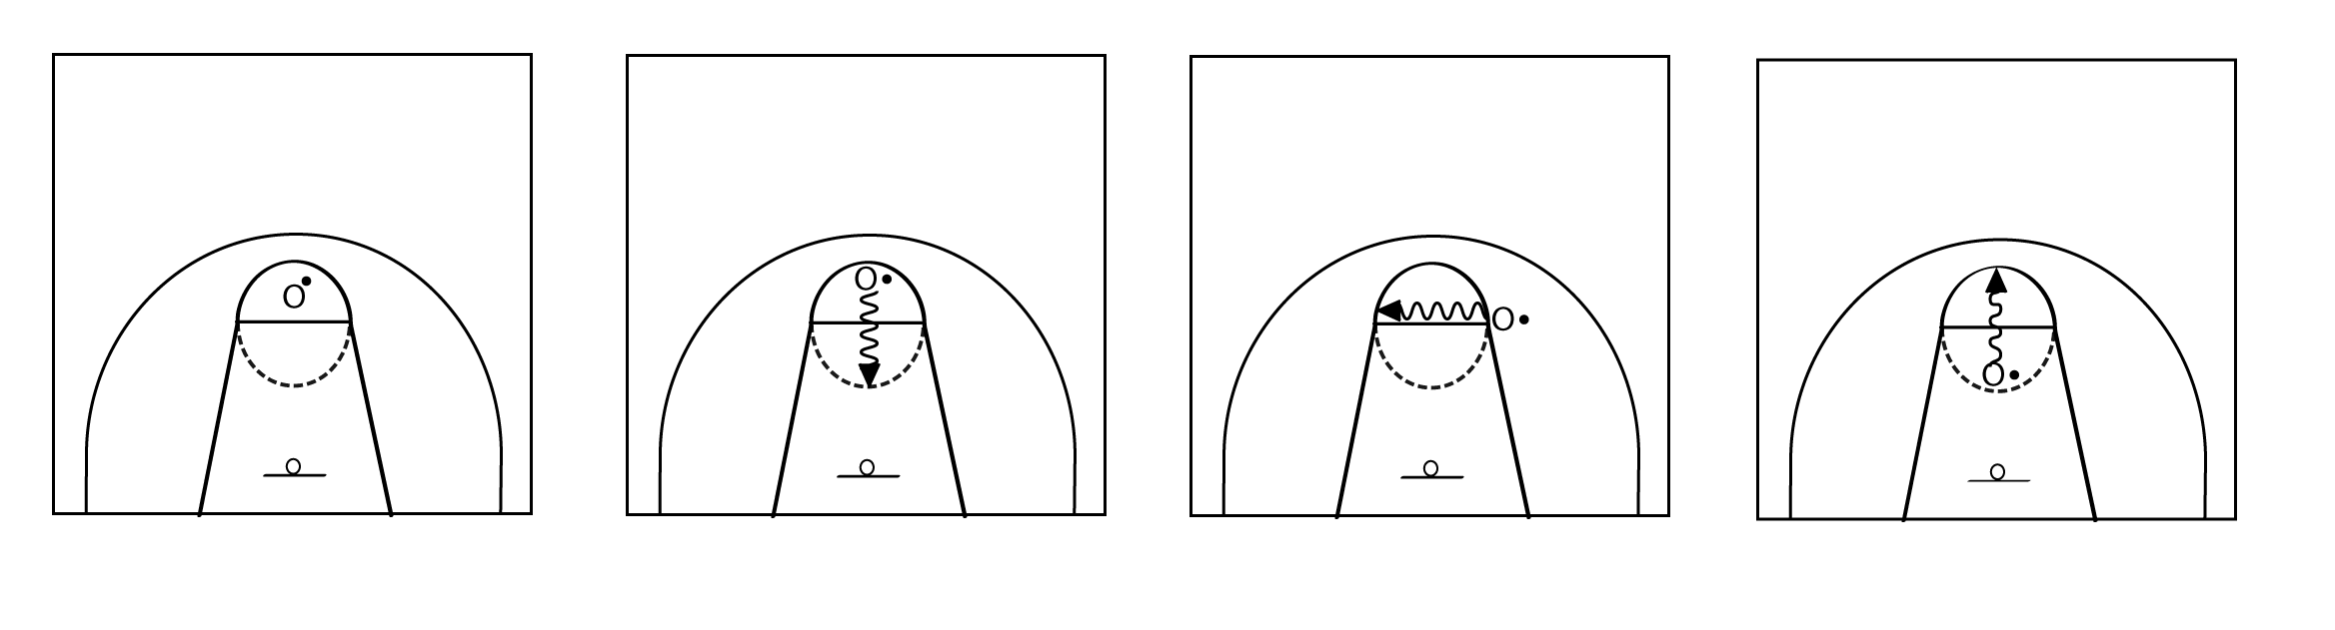

Key | X = defensive player
 | O = offensive player
 | O• = offensive player has ball
 | ----- = ball movement pass
 | → = player movement
 | = marker
 | = dribble

Drill description
  - Player faces the basket and executes a control dribble in a stationary position in the circle. Preferred hand then non-preferred hand.

Variations (where appropriate use preferred and non-preferred hand)
- Controls dribble moving forwards and remaining in the circle.
- Control dribble moving laterally and remaining in the circle.
- Control dribble facing perpendicular to the basket, but retreating backwards and remaining in the circle.
- Control dribble moving multi-directionally and remaining in the circle.
* Add defence to each drill

Drill 2: Speed dribble
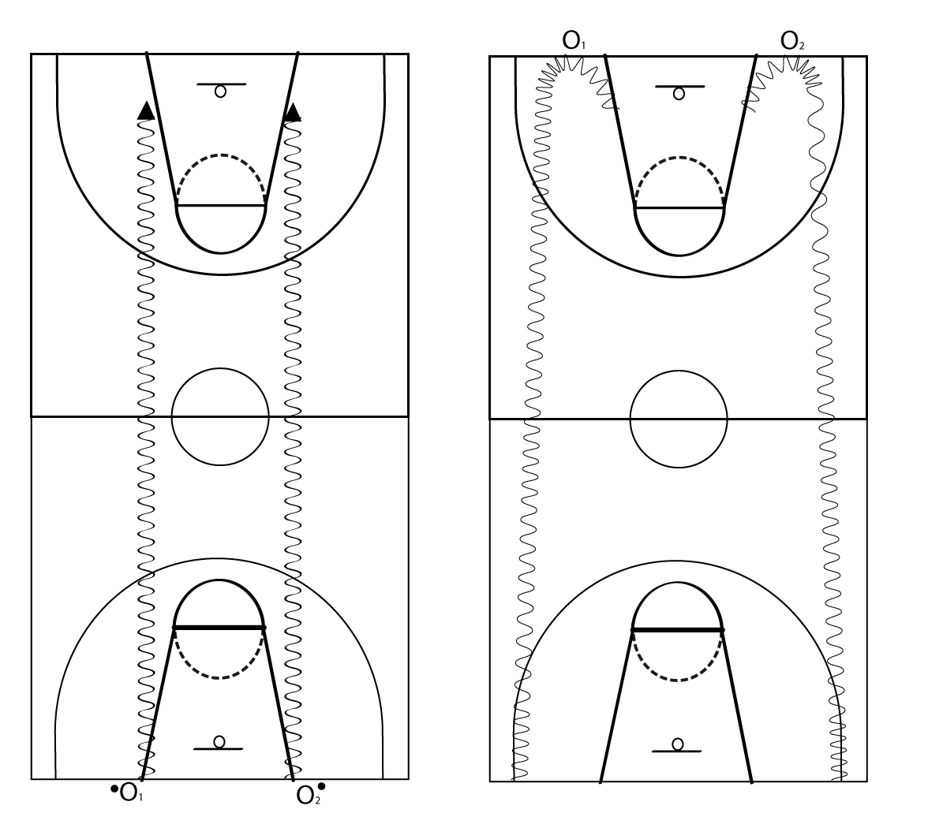
O₁ O₂
O₁ O₂
O O

Key | X = defensive player
 | O = offensive player
 | O• = offensive player has ball
 | ----- = ball movement
 | → = player movement
 | = marker
 | = dribble

Drill description
- O₁ starts at the baseline, facing the opposite basket.
- O₂ starts at the baseline on the opposite side of the court.
- Players perform a speed dribble to the base of the keyway at the opposite end of the court.
- O₁ left-hand dribble – O₂ right-hand dribble (players dribble using hand closest to the sideline).
- At the end of the dribble, players turn and face their original position and perform the speed dribble back down the court, using their opposite hand.

Drill 3: Offensive stance – triple threat (TT)
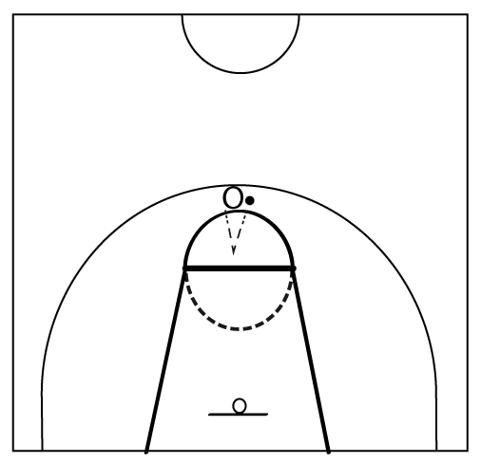

Key | X = defensive player
 | O = offensive player
 | O• = offensive player has ball
 | ----- = ball movement
 | → = player movement
 | = marker
 | = dribble

Drill description
- Player starts with the basketball at the top of the keyway and executes a ‘spin-back’ (spin the ball backwards so that it lands two metres in front of them and bounces back to them at waist height).
- The player catches the ball from the spin-back in the triple threat position.

Variations
Use preferred and non-preferred pivot foot.
- Shot fake and return to triple threat stance.
- Drive fake and return to triple threat stance.

Drill 4: Pass (uncontested) chest or push

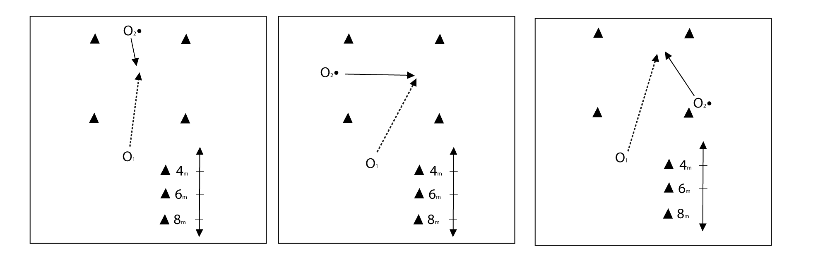

Key | X = defensive player
 | O = offensive player
 | O• = offensive player has ball
 | ----- = ball movement
 | → = player movement
 | = marker
 | = dribble

Drill description
- O₁ is positioned 4m, then 6m, then 8m from O₂, who is the target.
- From the offensive ‘stance’ position, O₁ is to execute a chest pass with flat trajectory to the target.
- Complete passes at 4m, then 6m, then 8m.
Variations
      - Moving receiver-direct (towards pass).
Chest pass
      - Moving receiver-angle (lateral pass).
      - Moving receiver-away from passer.
      - Repeat 1–3 with preferred hand – push pass.
      - Repeat 1–3 with non-preferred hand – push pass.

Drill 5: Leading-wing lead
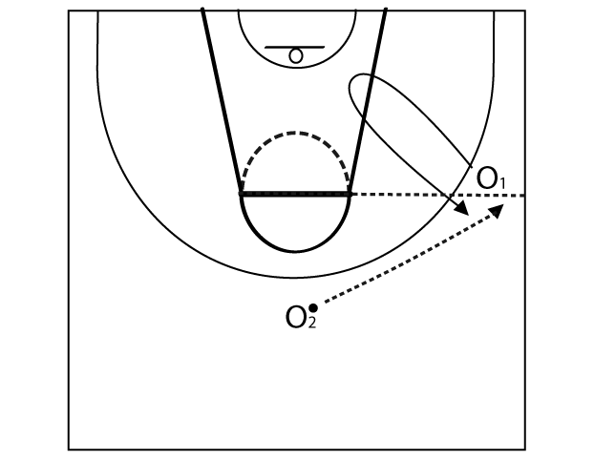

Key | X = defensive player
 | O = offensive player
 | O• = offensive player has ball
 | ----- = ball movement
 | → = player movement
 | = marker
 | = dribble

Drill description
- O₁ starts on the wing (free throw line extended to three-point line).
- O₁ sprints to basket – baseline hand is extended as a target for passer O₂.
- O₁ stops in the keyway and completes a ‘slash arm’ and forward pivot facing towards the ball at the top.
- O₁ sprints back out to the wing-baseline hand as target.

Drill 6: Closeouts – wing closeouts

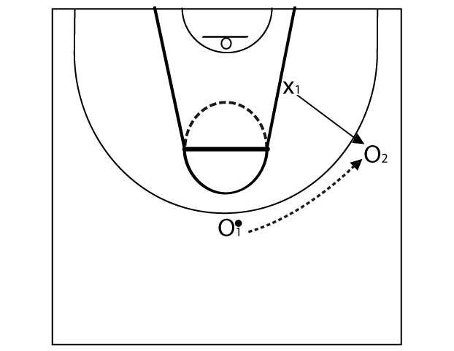

Key | X = defensive player
 | O = offensive player
 | O• = offensive player has ball
 | ----- = ball movement
 | → = player movement
 | = marker
 | = dribble

Drill description
- O₁ starts at the top of the key with the ball.
- O₂ starts on the wing.
- X₁ starts on the block (low post), facing the ball (O₁).
- When O₁ passes the ball to O_{2,} X₁ must execute a closeout on O₂, who will catch the ball and square up to the basket.

Drill 7: Defensive slide

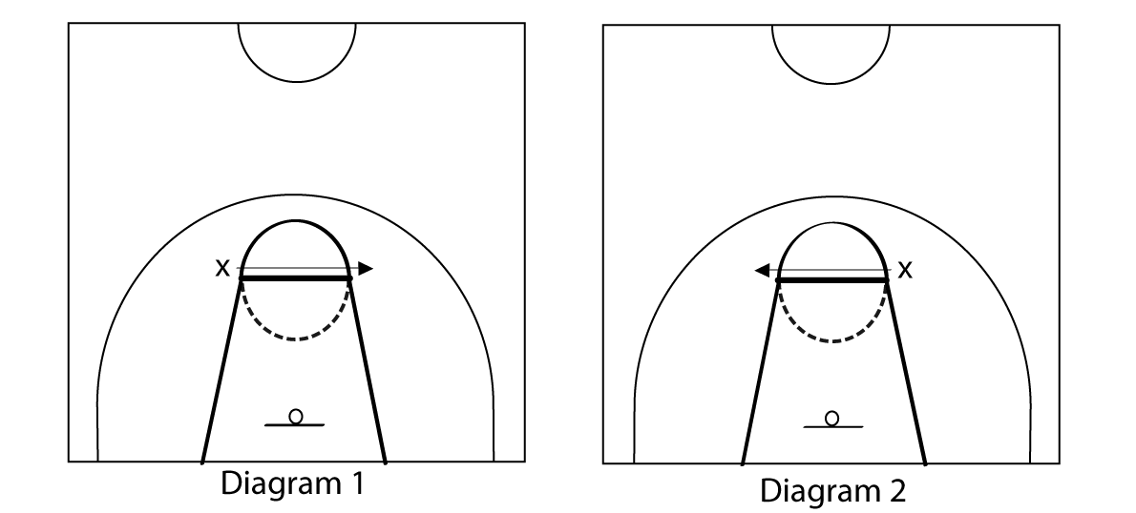

Key | X = defensive player
 | O = offensive player
 | O• = offensive player has ball
 | ----- = ball movement
 | → = player movement
 | = marker
 | = dribble

Drill description
- Player starts with both feet outside the circle.
- X will execute a defensive slide across the free throw line.
- Both feet must exit the circle on either side of the free throw line.
- X must slide over and back three times as efficiently as possible whilst maintaining the defensive stance.

Drill 8: Shooting – free throw
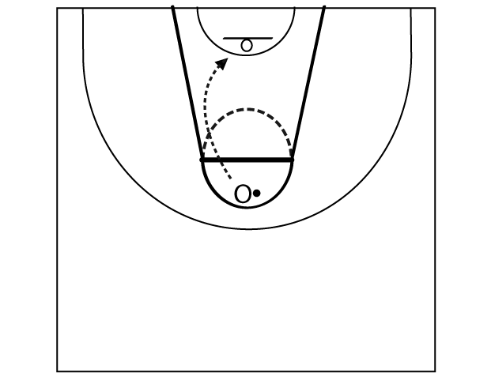

Key | X = defensive player
 | O = offensive player
 | O• = offensive player has ball
 | ----- = ball movement
 | → = player movement
 | = marker
 | = dribble

Drill description
- Player lines up at the free throw line.
- Player performs a series of free throws to the basket.

Drill 9: Lay-up
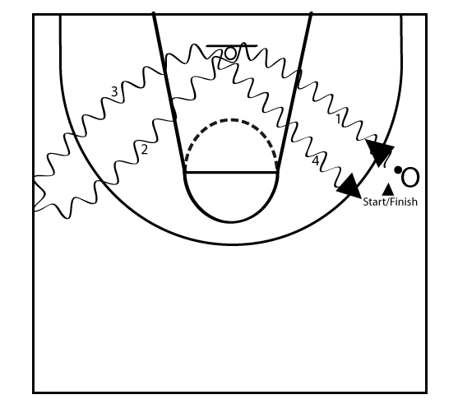

Key | X = defensive player
 | O = offensive player
 | O• = offensive player has ball
 | ----- = ball movement
 | → = player movement
 | = marker
 | = dribble

Drill description
- The player faces the basket from the right wing.
- Dribble with the right hand to perform a right-hand lay-up (1), rebound the ball and dribble with the left hand to the marker at the left wing (2).
- Turn and drive to the basket, dribbling with the left hand for a left-hand lay-up (3). Rebound the ball and dribble with the right hand to starting point, turn and repeat the drill (4).

Drill 10: Passing (contested), triple threat, closeouts
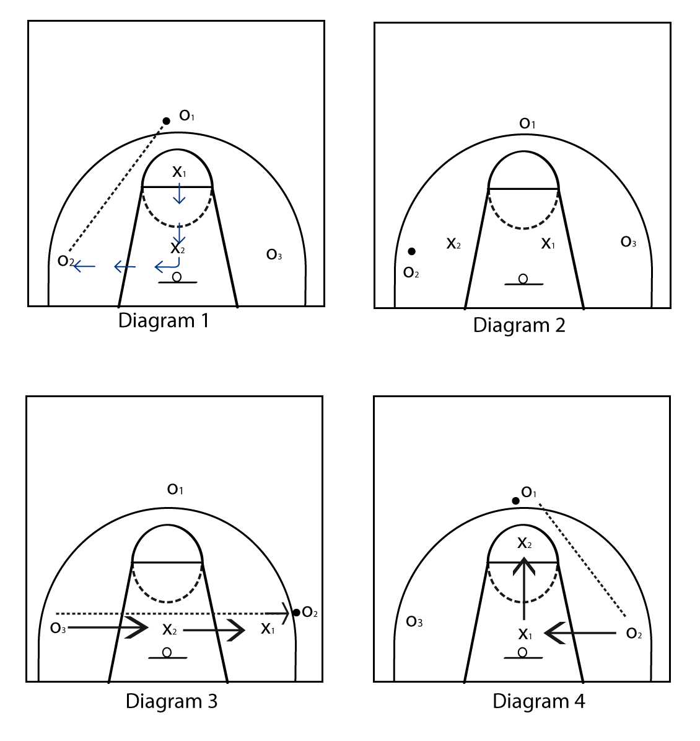

Key | X = defensive player
 | O = offensive player
 | O• = offensive player has ball
 | ----- = ball movement
 | → = player movement
 | = marker
 | = dribble

Drill description
- Offence (O_{1,} O_{2,} O₃) cannot dribble the ball, only passing is permitted. Overhead or push passes can be made between any of these three players. Offensive players must remain in their area.
- The offence must hold the ball for a two-second count before allowing the next pass (this allows the defence to move to position).
- The drill starts with X₁ guarding the ball player (O₁) and X₂ guarding the basket (help defence) (diagram 1).
- Ball is passed and X₂ gets to the ball to apply pressure (diagram 2).
- X₁ now drops to become the help defender (diagram 2).
continued over

- On the next pass, the help defender rotates to the ball in an aggressive closeout to pressure the ball.
- On each catch, the offensive player must wait for a two-count before passing to either offensive player.
- Offence is trying to complete accurate passes while the defence is trying to deflect the pass.

Drill 11: Shooting – catch and shoot jump shot

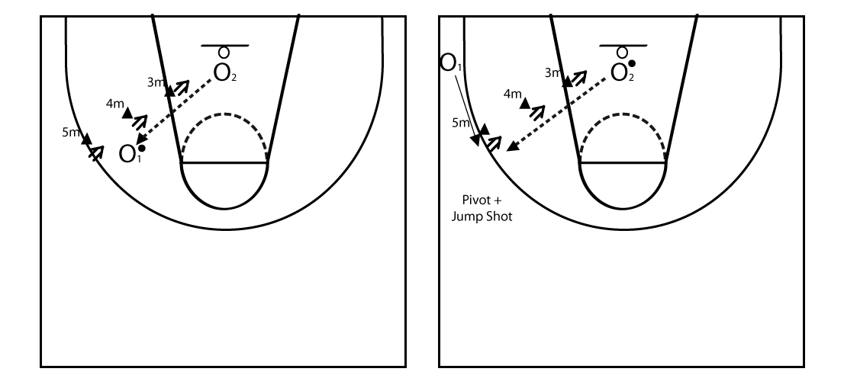

Key | X = defensive player
 | O = offensive player
 | O• = offensive player has ball
 | ----- = ball movement
 | → = player movement
 | = marker
 | = dribble
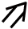
= shot

Drill description
- O₁ shoots a jump shot from markers 3m, 4m and 5m off a pass from O₂. O₂ is under the basket or at the top of the key outside the three-point line.
- In the next phase of this drill, O₁ starts in the corner and runs to wing to receive pass from O_{2.} O₁ catches and pivots into a jump shot. This is repeated at 3m, 4m and 5m.

Drill 12: Shooting – one dribble jump shot

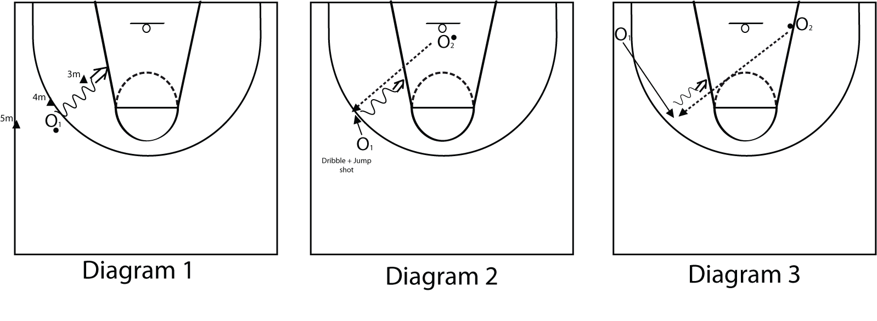

Key | X = defensive player
 | O = offensive player
 | O• = offensive player has ball
 | ----- = ball movement
 | → = player movement
 | = marker
 | = dribble
 | = shot

Drill description
- O₁ dribbles in to shoot a jump shot from markers at 3m, 4m and 5m (diagram 1).
- In the second phase, O₂ is under the basket. O₁ starts above the extension of the free throw line, runs forward to receive a pass on the wing from O₂. O₁ catches and executes an onside dribble before shooting a jump shot (diagram 2).
- Finally, O₂ is level with the basket and on the edge of the keyway. O₁ starts in the opposite corner, runs forward to receive a pass from O₂ and then executes a cross-over dribble before shooting a jump shot (diagram 3).

Drill 13: Screening-middle on ball
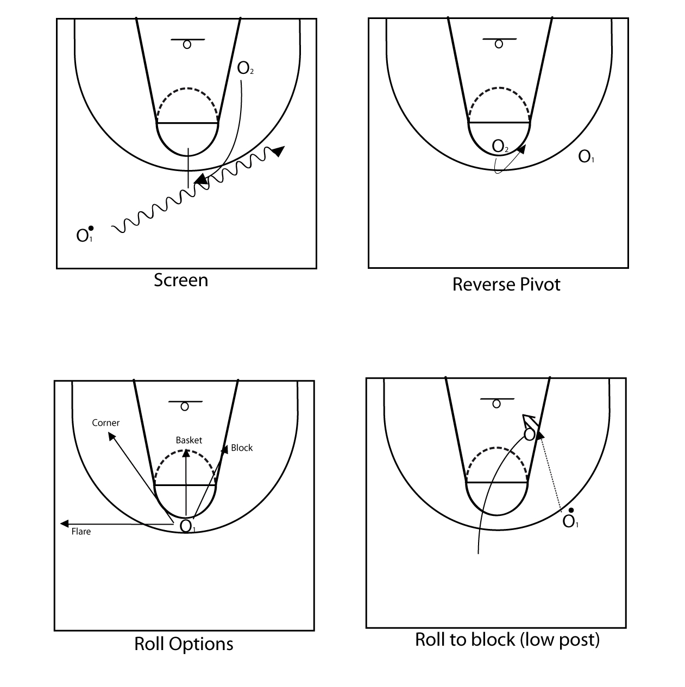

Key | X = defensive player
 | O = offensive player
 | O• = offensive player has ball
 | ----- = ball movement
 | → = player movement
 | = marker
 | = dribble
 | = screen
 | = = block
 | = shot
continued over

Drill description
- O₂ (screener) starts on block (low post).
- O₁ (dribbler) starts on opposite side, near halfway line.
- O₂ sprints from block to top of circle to set screen.
- O₁ dribbles towards basket until level with screen.
- O₂ jump stops facing the dribbler.
- O₁ dribbles past screener ‘shoulder to shoulder’.
- O₂ reverse pivots to face ‘belly to ball’ then rolls to either the low post block, the basket, the corner or the flare.
- O₁ can pass to O₂ at the low post block for a shot.

Drill 14: Screening – downscreen

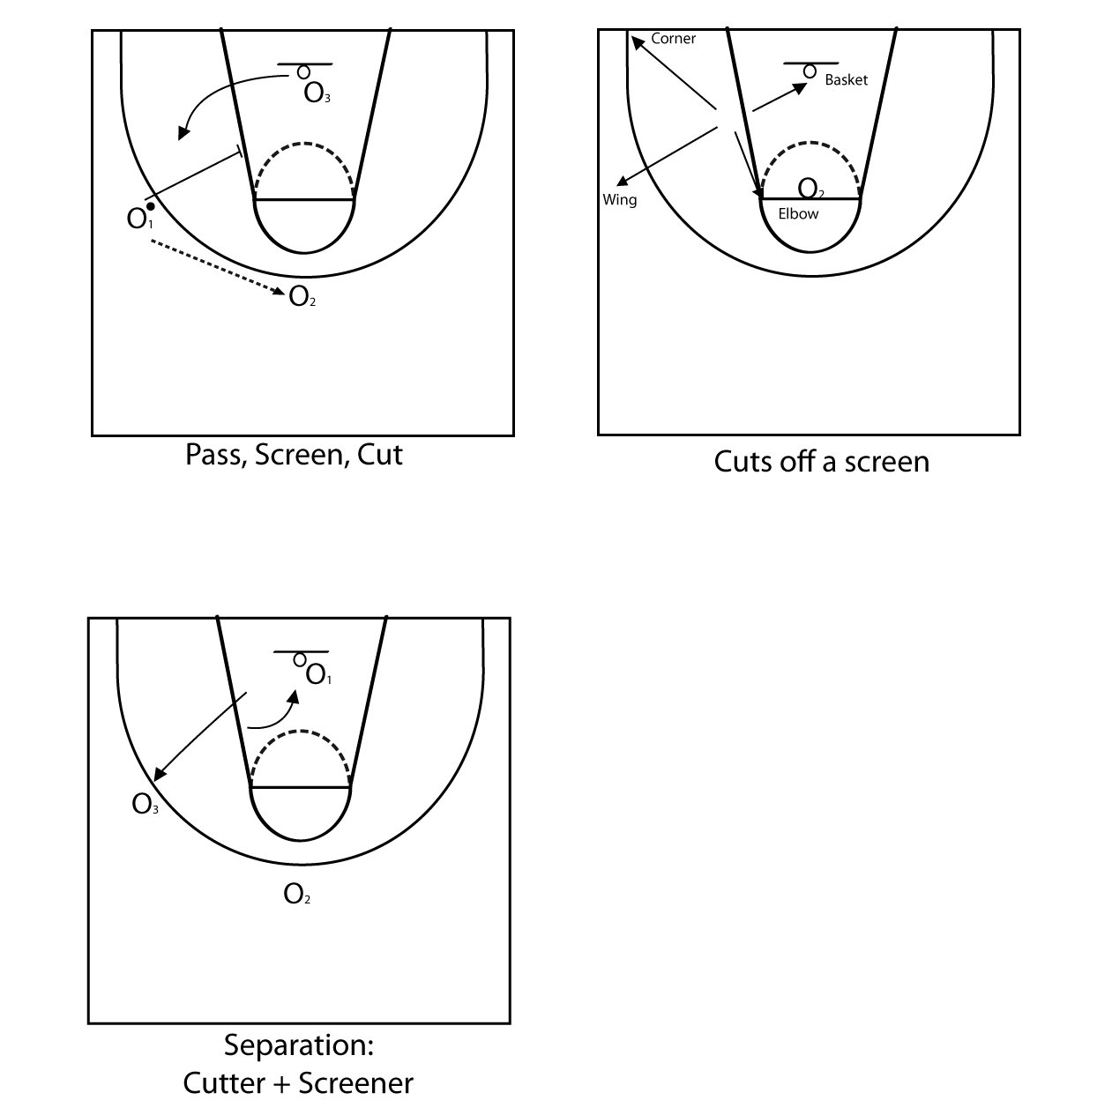

Key | X = defensive player
 | O = offensive player
 | O• = offensive player has ball
 | ----- = ball movement
 | → = player movement
 | = marker
 | = dribble
 | = screen

continued over

Drill description
- O₁ starts on the wing with the ball.
O₂ starts at the top of the keyway.
O₃ starts under the basket.
- O₁ passes to O_{2.}
O₁ sprints to the block, comes to a jump stop to set screen for O_{3.}
- O₃ cutter moves towards screener’s baseline shoulder, once in line with the screener’s shoulder O₃ decides on which cut to execute.
Based on O₃’s cut, O₂ will execute the opposite cut (separation between cutter and screener achieved).

Drill 15: Defence – on ball containment (control dribble, defensive slide)

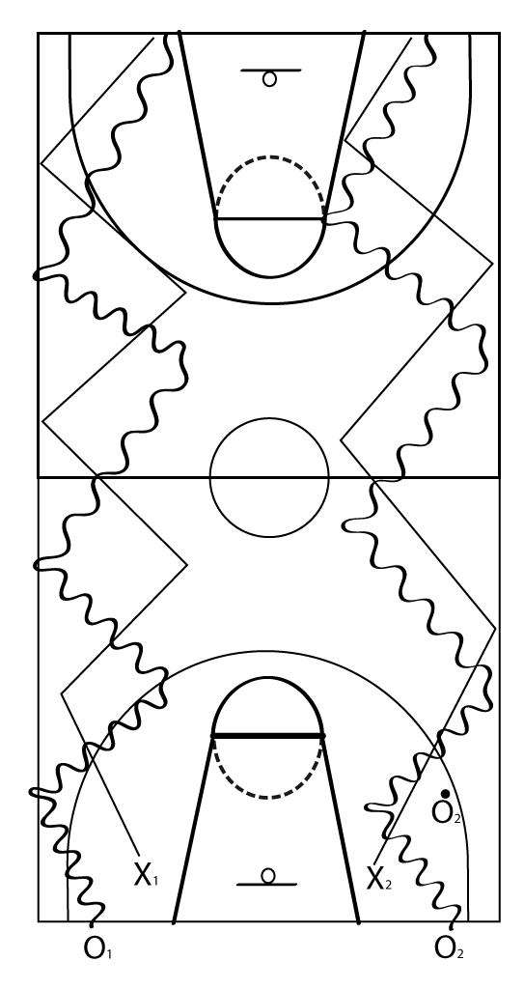

Key | X = defensive player
 | O = offensive player
 | O• = offensive player has ball
 | ----- = ball movement
 | → = player movement
 | = marker
 | = dribble

Drill description
- O₁ and O₂ are offensive players. Each has a defensive player guarding them.
- Using a ‘control dribble’, the offensive players dribble in a zig-zag pattern down the court, changing direction with an angular direction change and a hard push-off from the outside foot.
- Defence must stay with the offensive players in proper defensive stance (head in line with the ball and one-arm’s length away from the ball carrier) using a defensive slide.
- At each change of direction, the defensive player MUST execute a drop-step (using the leading foot as the pivot foot).

Basketball tactical framework

Tactical problems | Off-the-ball skills | On-the-ball skills
OFFENCE
Maintaining possession | - Create and maintain space  - Leading: speed cut, V-cut  - Cutting: basket, shallow | - Triple threat position  - Passing  - Catching – target hand, jump and stride stop, (TT: catch in the air)  - Pivoting  - Fake Series: drive, pass and shot  - Offensive rebound
Attacking the basket | - Flash cuts  - Leading  - Creating and maintain space  - Cutting | - Free Throw  PERIMETER SKILLS  - Set Shot  - Catch and shoot jump shot  - Crossover and onside jump shot  - Lay up, power lay up  - Ball reversal  POST SKILLS  - Baseline and middle drop steps and counters  - Pivot and face jump shot, fake series, counters
Creating space | - Fast break  - Down screen  - Up screen  - Back screen  - Receiver’s principles | - Ball reversal  - On-ball screen actions  - Screener actions: slip (to basket), “roll options” – (TP: belly to the ball) basket, block, short corner, perimeter  - Ball handler actions: dribble penetration – split/gap, runner/lay-ups, jump shot
Using space | - Pass and cut  - Down screen actions  - Off-ball screening actions (back, up, down, across)  - Cutting actions: straight, back, curl, flare  - Separation (between screener and cutter) | - Dribble entry  - Dribble hand-off  - Hesitation, retreat, freeze, crossover, onside dribbles

Basketball tactical framework

DEFENCE
Defending space (Half court) | - Stance – “pistols”  - Rotation on dribble penetration  - Help and recover  - Blocking out (off ball)  - Split line awareness  - Positioning (in relation to the ball) | - Containment defensive footwork  - Hand position, head position  - Channelling dribbler  - Turning the dribbler  - Blocking out (on ball)  - Defensive spacing
Defending the basket area (key) (Half court) | - Blocking out  - Rebounding  - Helping on post – ballside, helpside  - Stance – TT: “pistols” point to ball and player | - Defending the low post  - Defending the high post  - Blocking out  - Rebounding
Defending the ball (Full court) | Positioning  - 1/3 – 2/3 rule (flat triangles)  - Split line  - Line of ball  - Stopper/trapper  - Wing denial  - Interceptors  - Safety | - Turning, channelling  - Containment  - Run and jump (full court)
RESTARTING PLAY
Jump Ball  Inbounding the ball  Free Throw | - Jump ball alignment  - Defending baseline out-of-bounds  - Defending sideline out-of-bounds  - Free throw alignment  - Blocking out | - Blocking out in jump ball  - Pressuring inbounds pass (baseline/sideline)  - Free throw (block out shooter)

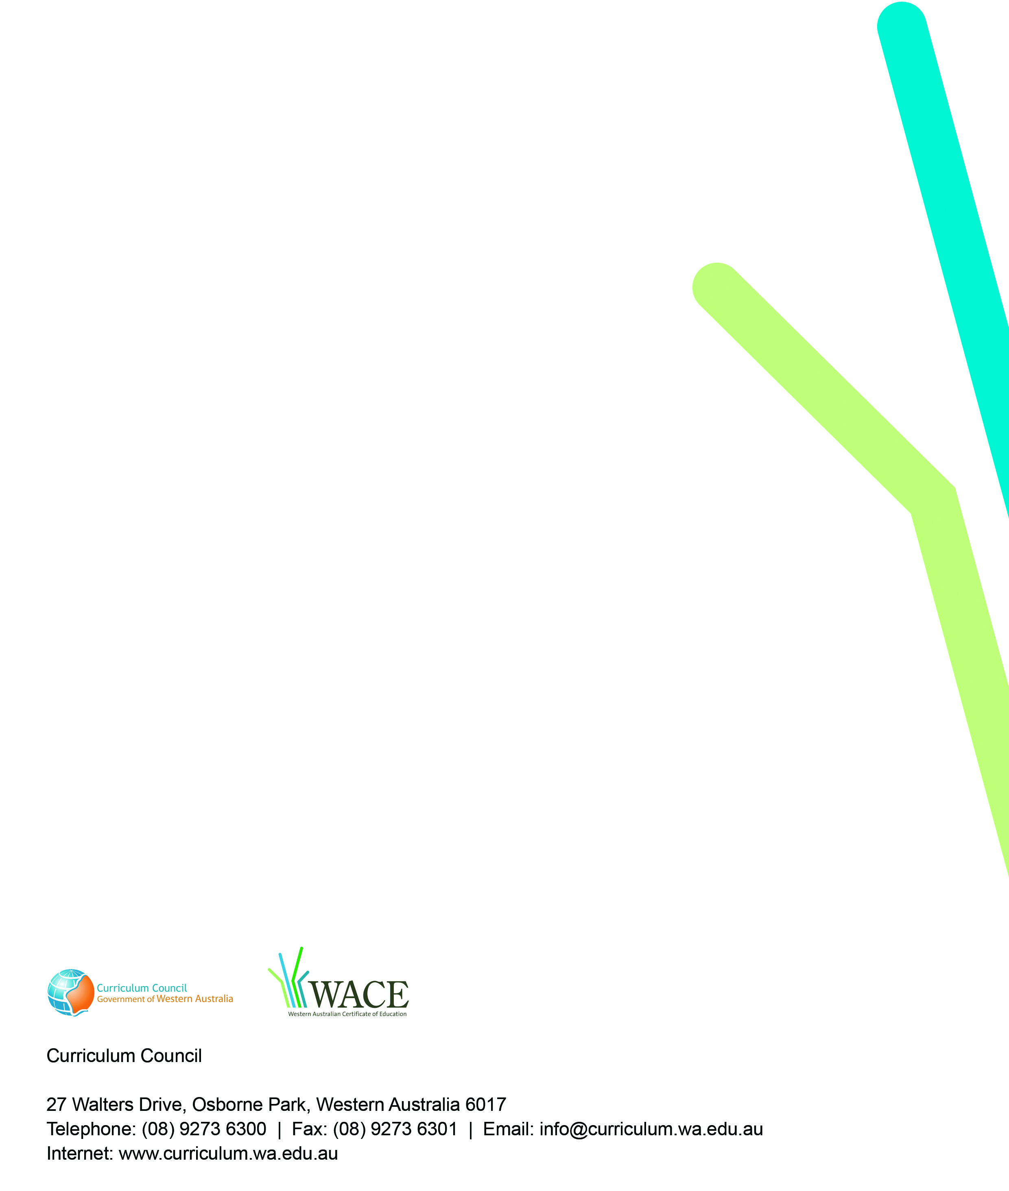
2009/8131[v3]

